Permutation Analysis – Null simulated phenotype-genotype to assess false positive rate/ type I error

Methods
To estimate each correction method's empirical false-positive rate, we generated null phenotype distributions by permuting the observed EOD/LOD status (n = 623 EOD, n = 917 LOD) across samples using a Fisher-Yates shuffle, which preserves the overall EOD:LOD ratio (0.69:1) while eliminating any true genotype-phenotype association. For each variant in both simulation sets, we generated 20 independent permutations (seeded for reproducibility) and processed the resulting null phenotype files with pyseer, with the same correction methods used in the power simulations. The empirical false-positive rate was calculated as the proportion of null simulations per variant and method yielding a likelihood-ratio-test p-value below the Bonferroni threshold (2.55 × 10⁻⁶). We additionally estimated the upper bound of the true Type I error rate for each bin using a rule-of-three approximation (3/n, where n is the number of contributing null simulations), valid at 95% confidence when zero events are observed across n independent trials (Jovanovic & Levy, 1997).
Results
As a sanity check on the permutation procedure, we examined the crude odds ratio (from the uncorrected effect size estimate) across null replicates by allele frequency bin (Figure S3A). Unlike the systematic bias expected under the artificially enriched ratios used in the power simulations (Figure 2/S2), the crude OR was centered on ≈1 across all allele frequency bins (0.05–0.95, n = 10 SNPs each), confirming the permutation removed genotype-phenotype association without introducing bias.
The false-positive rate observed across pyseer results was 0%, at every allele frequency bin (Figure S3B) and homoplasy index bin (Figure S3C) across all 13 correction methods. However, observing zero significant results across a finite number of null simulations does not guarantee a true Type I error rate of exactly zero. Given the number of null simulations contributing to each bin (200 permutations per AF bin for Set 1, and 240–420 permutations per HI bin for Set 2), a rule-of-three approximation places the upper bound of the true Type I error rate at approximately 1.5% for Set 1 and 0.7–1.25% for Set 2, with 95% confidence.
Discussion
The upper-bound Type I error rate estimated from our permutation analysis was low (0.7–1.5% at 95% confidence), providing no evidence of inflated false-positive rates across methods. This indicates that the elevated power observed for some correction methods at high homoplasy (e.g., FastTree DP FEM, No correction; Figure 4, Table 2) reflects genuine sensitivity to clonally distributed signal rather than inflated Type I error. Together, these results support that all methods were well calibrated under the null, and that the power differences reported in Figures 3–5 reflect true differences in detection sensitivity rather than differential false-positive rates.

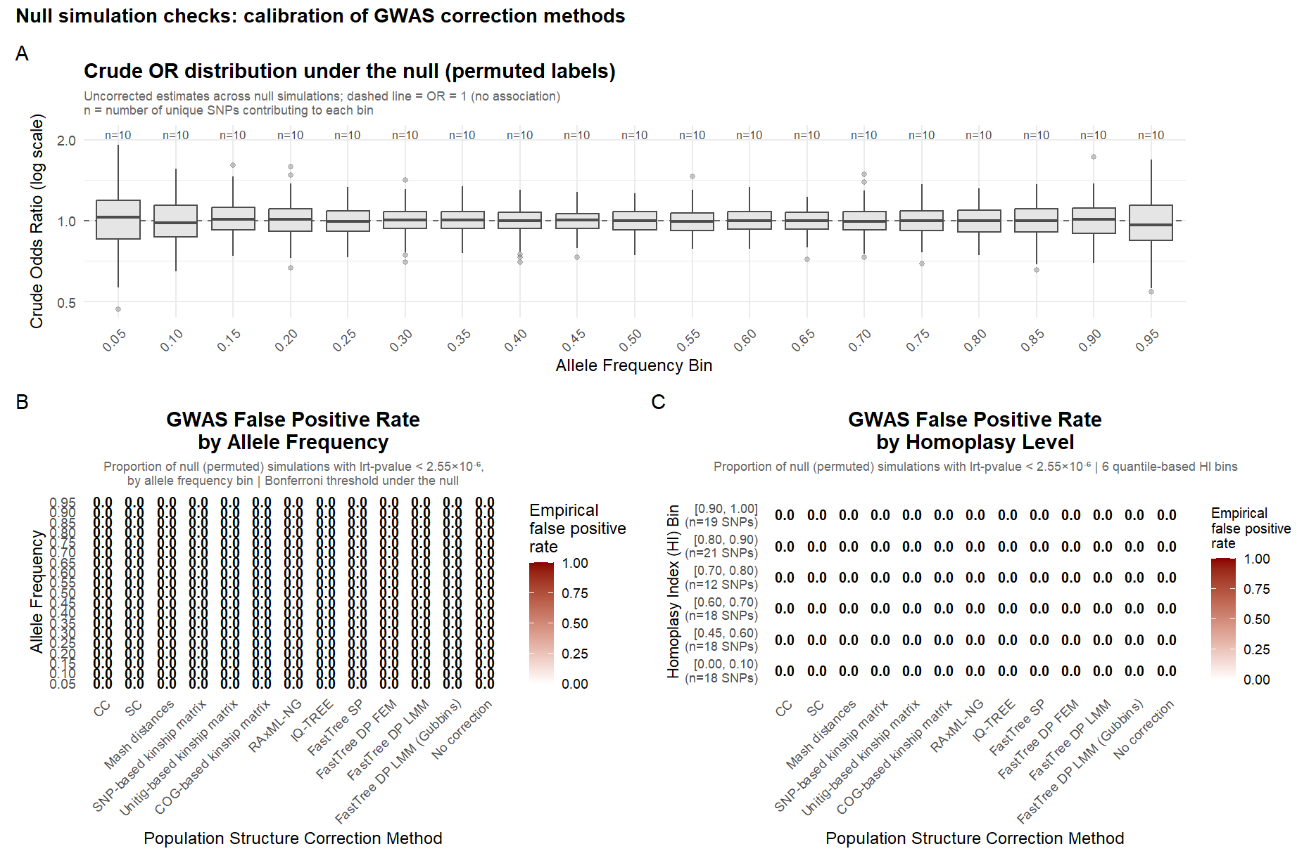
Figure SX. [Add title and caption]

